European Masterclass on pressure prevention and treatment
Ivanka Benčič, MSc, ET, Clinical Nurse Specialist at Sisters of Charity Hospital, Zagreb, Croatia

Organized by EPUAP, another European Masterclass on pressure prevention and treatment was held on 25-27 April 2022. Porto, Portugal. Ivanka Benčič, MSc, ET who is also a member of European Council of Enterostomal Therapy and member of Editorial bord for EWOCS (European Wound Ostomy Continence Supplement) has attended and successfully completed European Masterclass on pressure prevention and treatment.
The European Pressure Ulcer Advisory Panel (EPUAP) was created in London in December 1996 to lead and support all European countries in the efforts to prevent and treat pressure ulcers.
The EPUAP pressure ulcer masterclass was intended for specialized clinicians, nurses, researchers, it introduced us to the foundations of research activities, ways of education, challenges of prevention and treatment of pressure ulcers. The International Masterclass provided us with an in-depth theoretical and practical basis on the prevention and treatment of pressure ulcers. He was very interactive, practical and full of examples.
The partners in organizing the Masterclass course were:
- Uni versidade Católica Portuguesa
- The Royal College Of Surgeons In Ireland
- Ghent University
- University Centre For Nursing & Midwifery
- Charité-Universitätsmedizin
The main themes of the masterclass were:
- Aetiology and biomechanics of pressure ulcers
- Epidemiology, diagnosis and classification
- Prevention (including speci­fic patients populations)
- Treatment (with a focus on complex cases)
- Guidelines and guideline development
- Implementation, quality indicators, quality improvement projects
- Basic principles about research and pressure ulcers (including health economics)
The program also included:
- lectures by international renowned pressure ulcer experts
- workshops
- guided tour in the simulation centre
- complex case discussions
- group work
- networking event
- examination
The masterclass course was attended by a total of 22 participants from around the world (Australia, Saudi Arabia, Finland, Turkey, Germany, Belgium, Poland ... and 4 participants from the Republic of Croatia, which I am especially proud of). The information we received is based on evidence that can be used immediately to improve practice (clinical, research, industrial, innovation and educational). In my opinion, the event itself was brilliantly organized, very professional but also a pleasant and stimulating environment. Lectures were given by internationally recognized experts on pressure ulcers workshops very interactive. We had complex discussions of cases in small groups, led by experts and lecturers. I was also very impressed by the tour of the Wound Research Institute.The organizer also offered a good networking event, it was great to have the opportunity for new acquaintances and exchange of experiences.The final exam is an interestingly complex subject, certainly a stimulating message for further learning and professional development.
In conclusion, in later contacts with fellow participants, we expressed our satisfaction with the material obtained at the Masterclas course on pressure ulcers. Personally, I would recommend continuing to improve my knowledge in the field of health care for pressure ulcers.

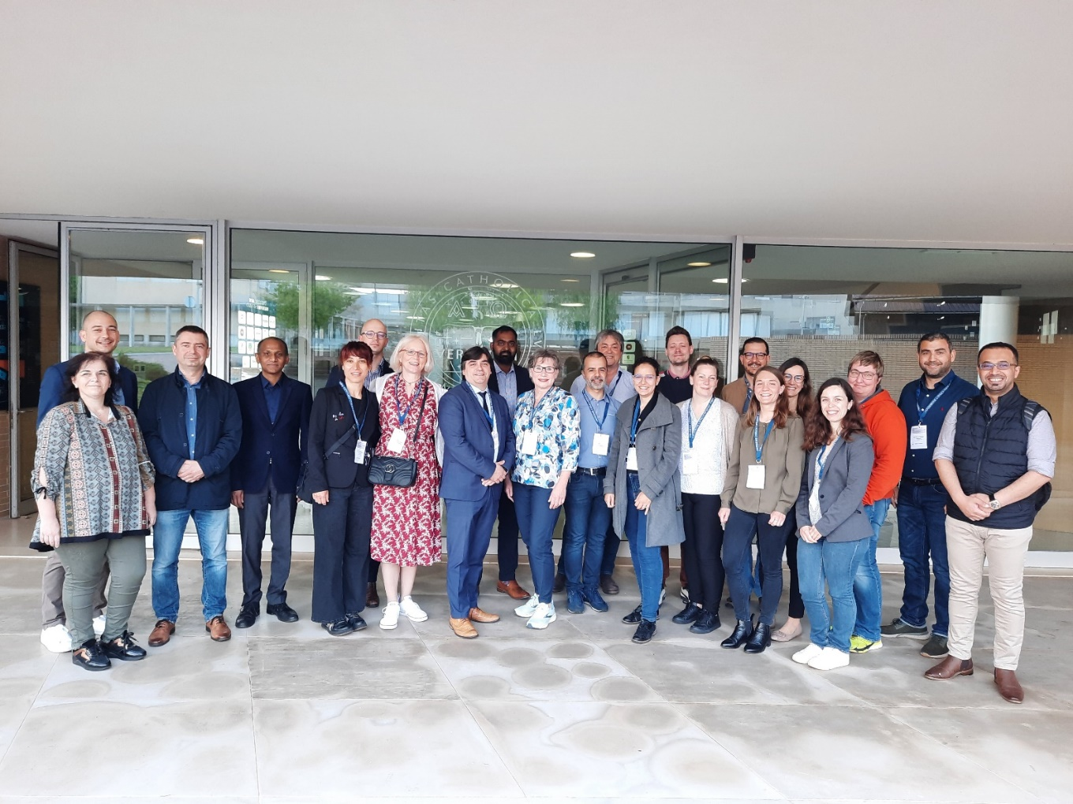
Picture 1: Ivanka Benčič, MSc, ET (seventh from the left side) with other participants of European Masterclass on pressure prevention and treatment, 25-27 April 2022 in Porto, Portugal.

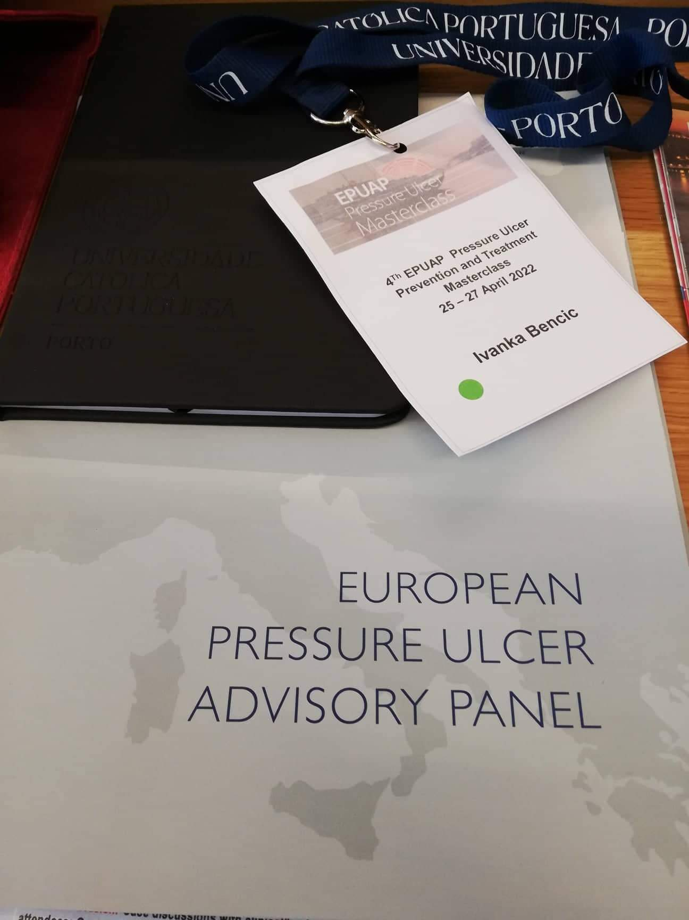
Picture 2: Certifikate of successful completion European Masterclass on pressure prevention and treatment.

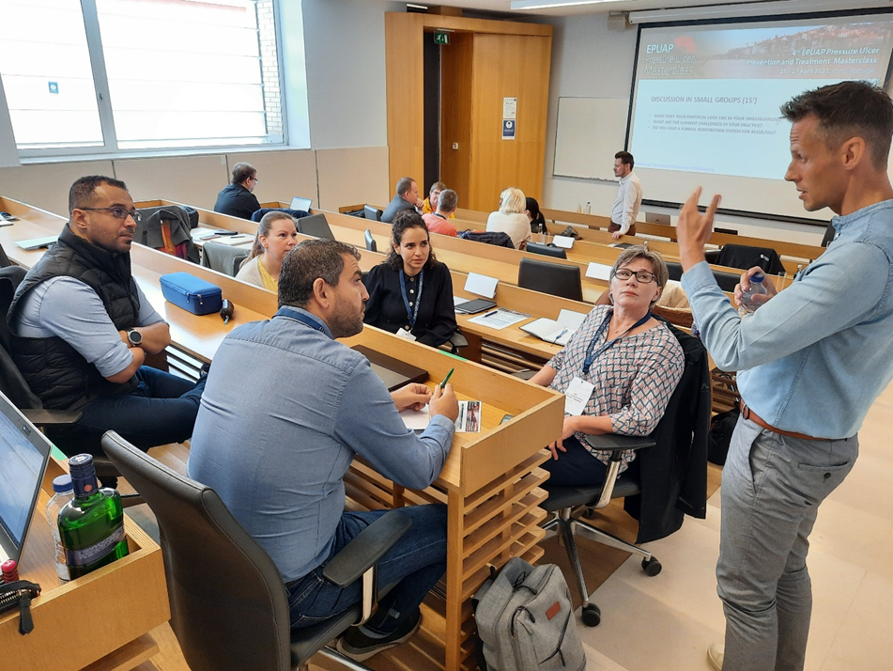
Picture 3: Lecturer at European Masterclass on pressure prevention and treatment Mr. Dimitri BeeckmanProfessor at Ghent University (Belgium) | Professor and Vice-Head of the School of Health Sciences at Örebro University (Sweden) | Skin and Wound Researcher | EWMA, ISTAP and EPUAP Executive | Globetrotter | 🇧🇪🇸🇪 (first from the right side).
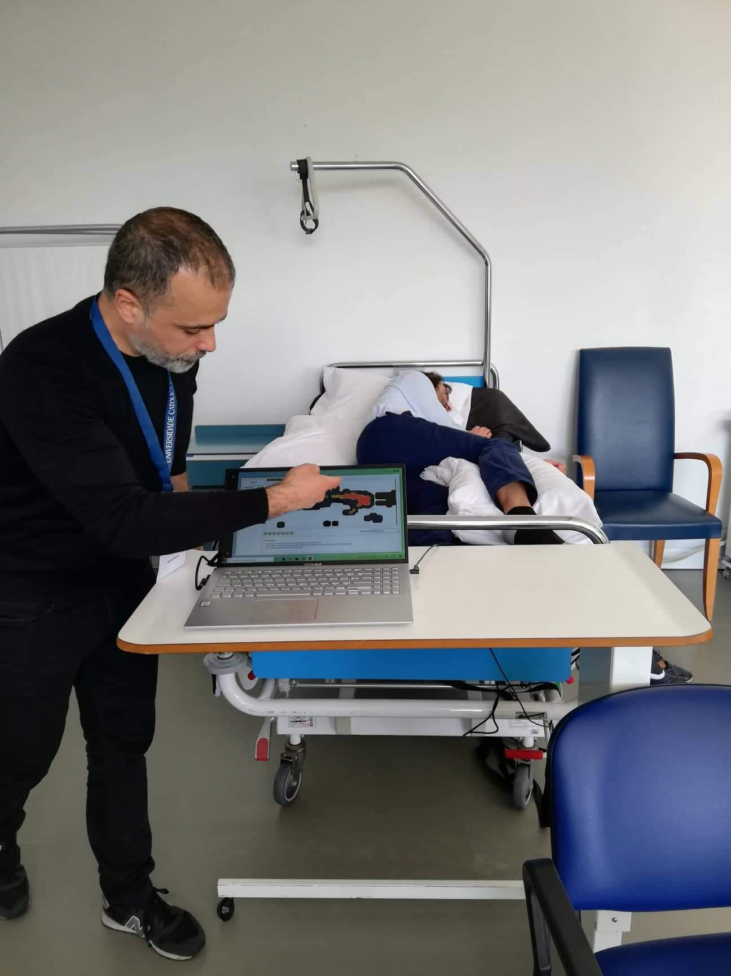
Picture 4: Workshop at European Masterclass on pressure prevention and treatment.

